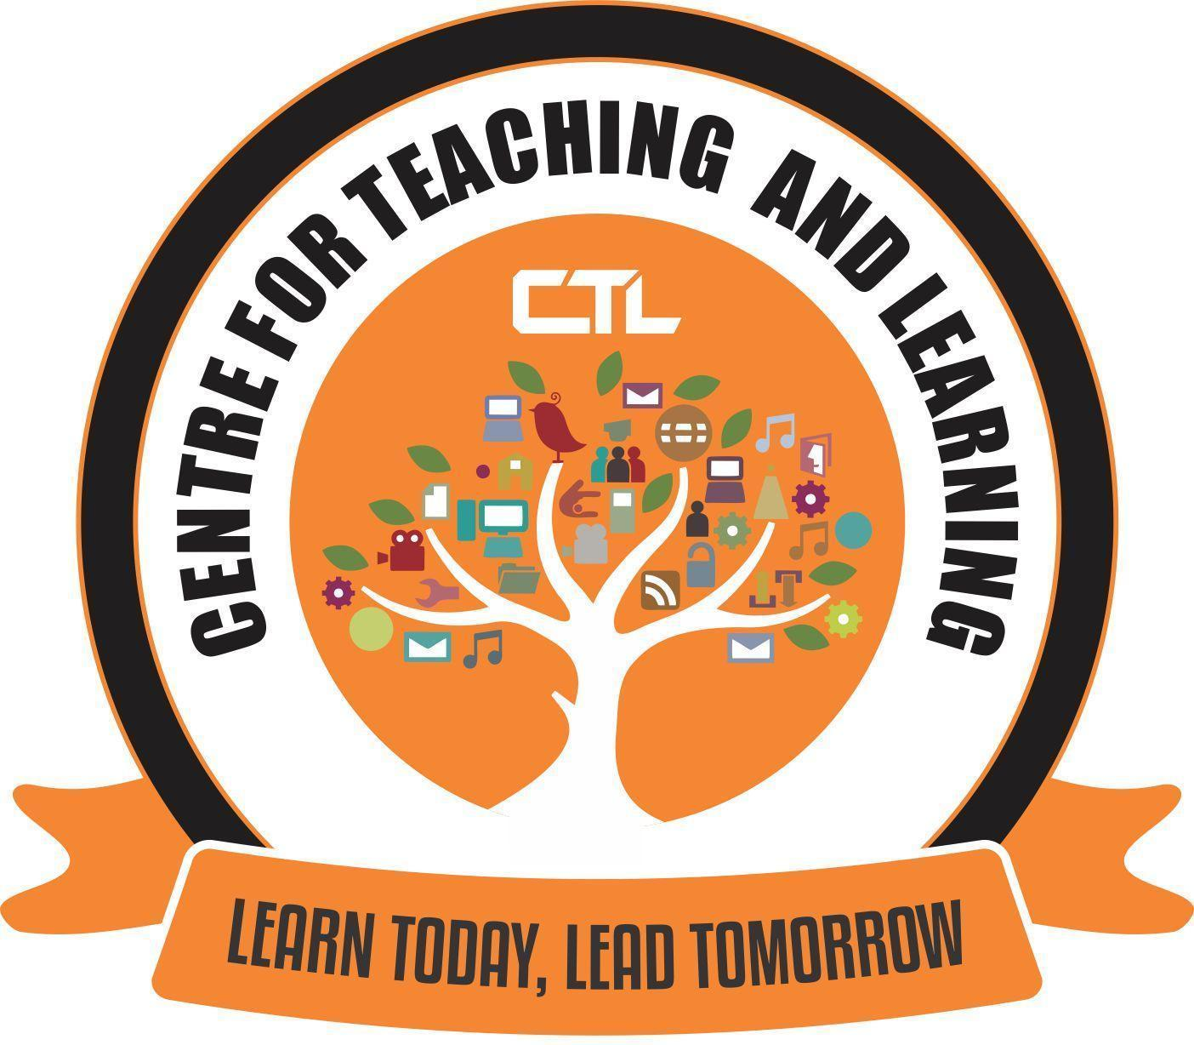
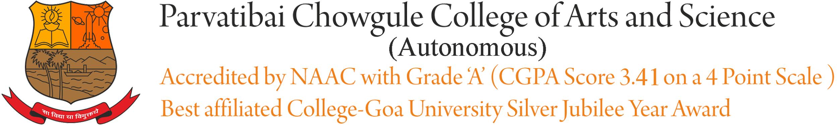

CENTRE FOR TEACHING AND LEARNING

REPORT ON
Title: | Orientation/Training Session on using the OBE Portal
Date and year: | 17th April, 2021
Venue: | Lower Auditorium
Resource person/s: | Ms. Dikshita Aroskar  Ms. Ashweta Anand Fondekar
Organising Committee | Center for Teaching Learning
No. of Participants: | 04
Objective: | The main objective of this session was to demonstrate the OBE portal and give hands-on training to our college faculty on the same.
Summary of the proceedings: | LOCF portal offers a structural approach for Storing, Updating and generating Reports of the data related to Course Outcomes. This portal is designed to offer an organized storage and retrieval mechanism of Course Outcome files for each course offered in the institution and access it whenever the need be.  In this orientation session, demonstration was given on the following:  -How to accept the invitation and join the portal.  -How to use the classroom.  - Creating links to upload course outcomes attainment files.  -what should be the naming convention to follow while creating a link.  -Uploading of Course Outcome files on the portal by the faculty members  -Storing and Retrieving of course outcomes attainment files submitted by the faculties.  -Checking the status of submission.  -How to display/view the submitted files of CO using google site.
Photographs:

Report Prepared by: Ashweta Anand Fondekar

